Church Walk Primary School DT Scheme of Work
Newlands Cycle Year 3 / 4 Cycle B |  | Year 3 Year 4 |  | Key Assessment Criteria
 | Autumn | Spring | Summer
Focus | Making  Viking Longboats  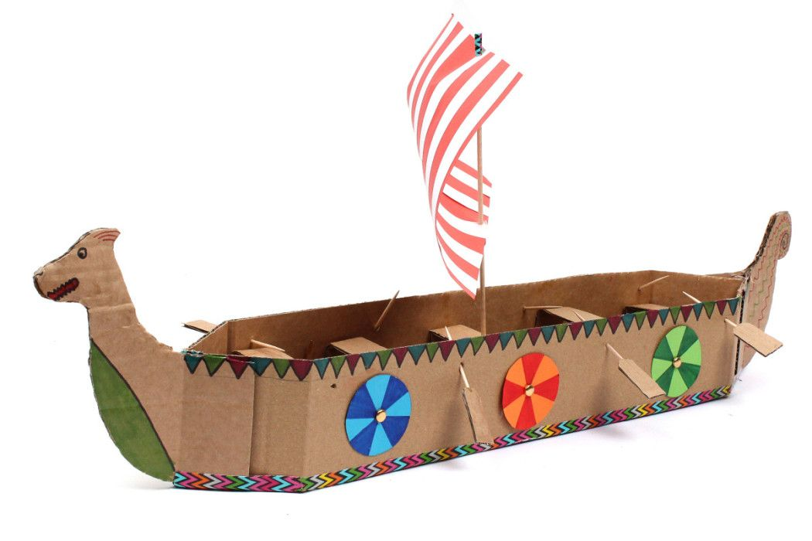  Making Torches | 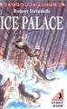  Make a bag for Ivan from the Ice Palace | Greek mask making  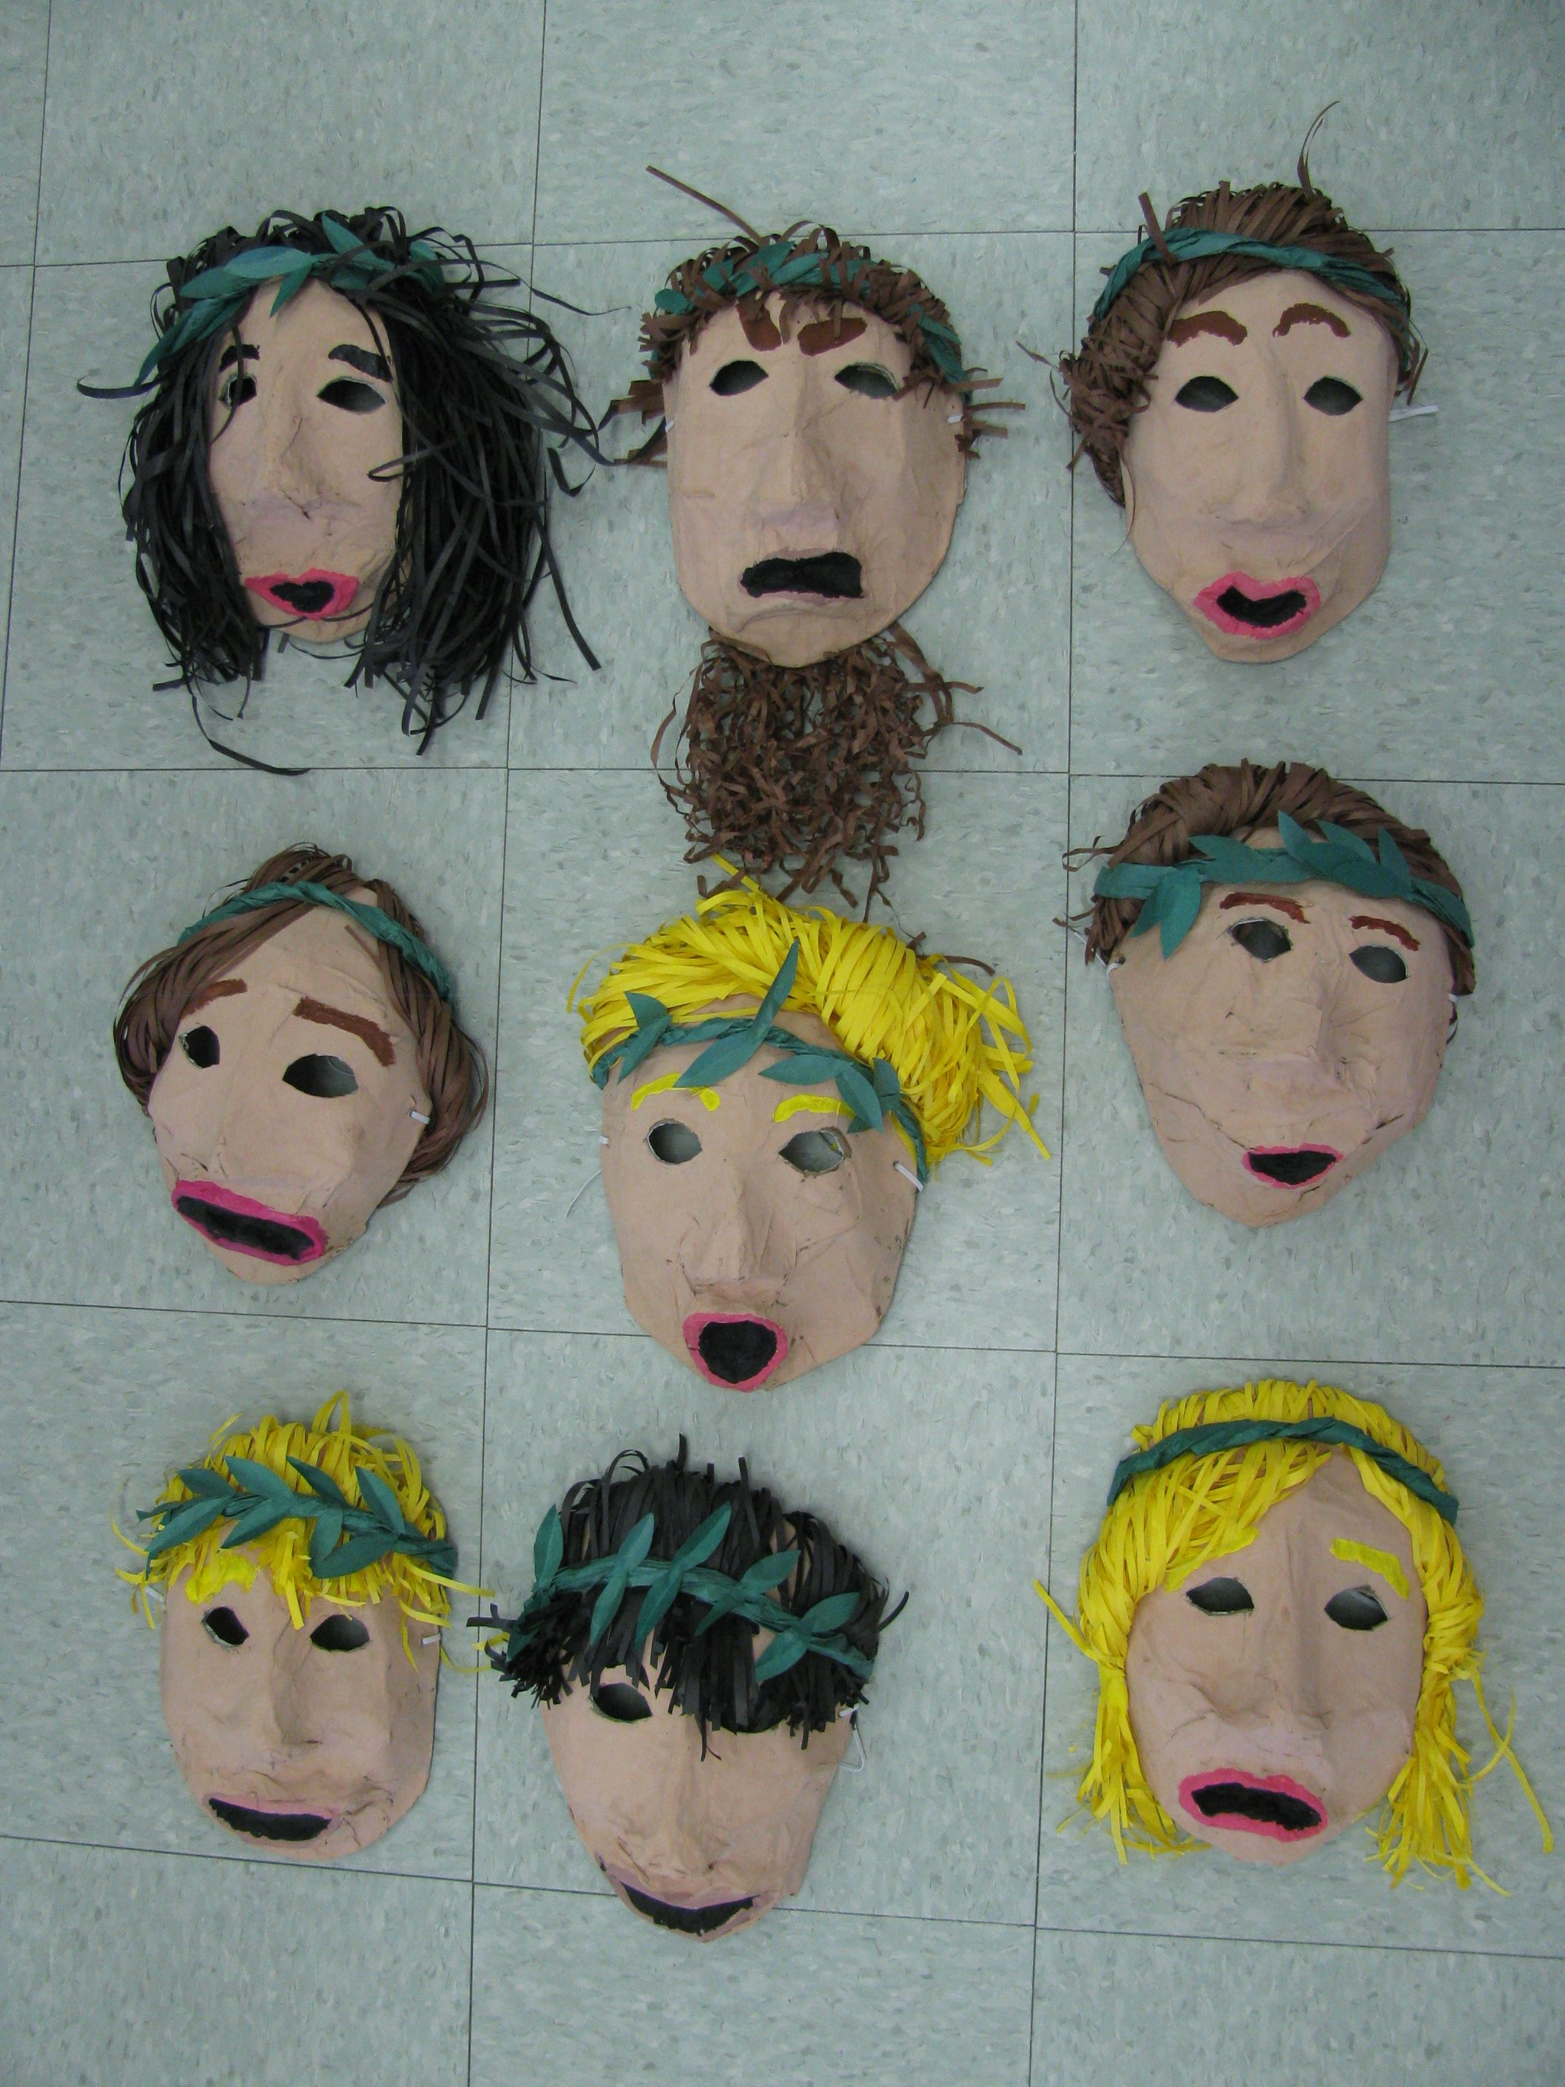  Greek Food | - I prove that my design meets some criteria  - I can follow a step-by-step plan,choosing the right equipment and materials  - I can design a product and make sure that it looks attractive  - I can choose a material for both its suitability and its appearance  - I can select the most appropriate tools and techniques for a given task  - I can make a product which uses both electrical and mechanical components  - I can work accurately to measure, make cuts and make holes  - I use ideas from other people when I am designing  - I produce a plan and explain it  - I evaluate and suggest improvements for my designs  - I evaluate products for both their purpose and appearance  - I explain how I have improved my original design  - I present a product in an interesting way  - I measure accurately  - I persevere and adapt my work when my original ideas do not work  - I know how to be both hygenic and safe when using food
Resources
Curriculum links | History : The Vikings  Literacy: Anthony Browne  Science: Electricity | Literacy | History: The Greeks
Skills | -Using research and making a plan according to criteria  -Use different joining and cutting methods related to paper, card and a range other materials  - Use construction kits  - Understand ways in which to make structures stable (free standing)  - decorative techniques  -accurate cutting, measuring and folding  - appropriate for its purpose / user  - teamwork in problem solving  - construct simple electrical circuits and switches  - Evaluate product carrying out tests | -Investigating functions of bags  ( sturdiness; waterproofing)  Additional features eg pockets, length of handles  Attaching techniques | -Making a plan according to criteria  - use different types of design (annotated sketches, cross-sectional and exploded diagrams, prototypes)  -Use different joining and cutting methods related to paper, card and a wider range of other materials  - Use construction kits  - Understand ways in which to make structures stable (free standing)  - Folds and flaps  - decorative techniques  -accurate cutting, measuring and folding  - - teamwork in problem solving  - construct simple electrical circuits and switches  - Evaluate product carrying out tests

